United International University
CSE 1116 - Final Exam - Set A

Write your name and ID on the question paper. Marks are on the right. Return question.

Q1. Implement a GUI using Java Swing that does the following tasks: [15 Marks]

- Components: 2 text fields and 1 button labelled SWAP
- User can write in both the text fields
- When the Swap button is clicked, the text of both the fields are swapped

Fig: Before Clicking Button  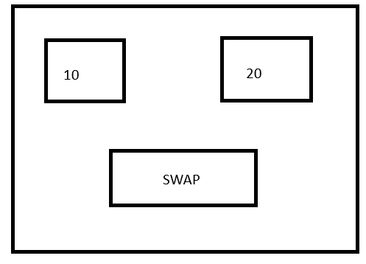 | Fig: After Clicking Button  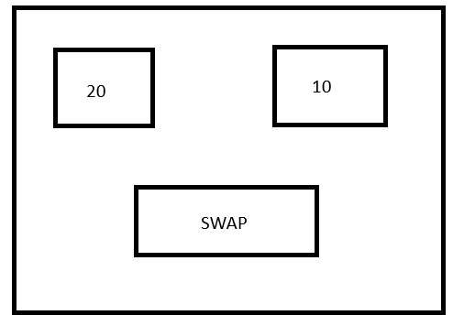

Q2. Write a Java code that implements the following system: [10 Marks]

- Interface Cookable - Method void cook(String food)
- Abstract Class Restaurant that uses Cookable
  - Attributes: String name, double rating
  - Constructor that takes both the parameters
  - Implement the cook(String food) method in the following way:
    - If the food is Pasta or Pizza or Burger, print a message stating that the given food is being cooked
    - If the food is not any of the 3 above, then throw an user-defined exception named InvalidFoodException with the message: Food not available
  - Abstract method void serve(String food)
- Class FastFoodRestaurant which is a subclass of Restaurant
  - Override the serve method printing a message stating that the given food is served
- Class FoodProgram which will have the main method
  - Create an object of FastFoodRestaurant
  - Call the serve() and cook() methods
  - Handle exceptions for invalid food in cook() method, and print the exception messages

